MAY HALF-TERM NEWSLETTER
Congratulations to our lovely learners, staff, old and new parents on the completion of a busy and successful half term. The BroadOak Schools is working in partnership with parents to improve school attendance. We would like to congratulate the many parents who make sure their children attend school regularly. As you all are aware, we strive to encourage the children to make the most of their time at school and to attend school every day. The school is working hard to meet its targets on attendance and we make every effort to work with the parents to achieve this as it is a parent’s legal responsibility to ensure that their child has a full education.
It has been our tradition to always set aside a day after the Continuous Assessment for parents to meet with their wards’ teachers to discuss the academic and all round progress of their wards and also deliberate on ways to help them improve. This half term’s open day will be coming up on Monday 29th May, 2023 from 10am to 2pm.Parents are encouraged to make out time from their busy schedules to attend this event. Please note that proxies are not allowed.

Mid-Term Holiday
We will be going on half-term holiday from Monday 29th May 2023 till Friday 2nd June, 2023. School resumes on Monday 5th May 2023. As we release our children to you, we trust you to take good care of them. We will appreciate if parents can insist and ensure that their wards do their half-term project.

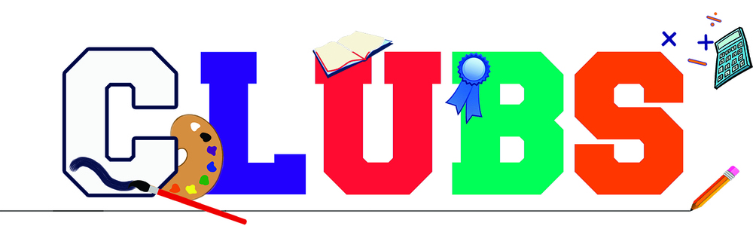
We have a number of existing clubs;
The Creative Arts club
The home makers club
The performance arts club,
The book and comic club
The coding club
We encourage parents to register their wards in a minimum of one club with the sum of ten thousand naira only. The children are really happy with the various club activities and will be exhibiting / showcasing a few of them during our various ceremonies.

Please be reminded that school resumes by 8:00am and closes by 4:00pm Mondays through Thursdays and 8:00am to 2:00pm on Fridays. We encourage parents to always endeavour to bring their wards to school on time as children brought to school after 8:00am will not be allowed into the school premises. Also be reminded that pickups after the 30 minutes grace period (4:30pm, Mondays through Thursdays and 2:30pm on Fridays) attracts a penalty of one thousand naira (N1, 000) per child.

SCHOOL UNIFORMS
Please note that all school uniforms are to be procured from the school procurement office. Please note that the school has zero tolerance for wearing of wrong school uniforms as defaulters will be sent home. We have the grey set for the primary and the blue set for secondary which are worn on Mondays and Wednesdays and the PE sets for both primary and secondary are worn on Tuesdays and Thursdays while the Friday traditional wears are for Fridays. We encourage parents to please place orders for uniforms on time as we may have thousands of items but may also run out of some sizes. So if you order on time, we will procure on time.

We would like to remind our dear parents about outstanding payments on fees, books and uniforms. To avoid any misunderstandings or restrictions, please endeavor to rectify outstanding payments as soon as possible as learners with outstanding payments will not be allowed into the school from 5th June, 2023.

ADMISSION/ENTRANCE EXAMS:
We shall be having our third entrance examination on the 10th May, 2023. Parents are encouraged to take advantage of this date. Admission forms are on sale in the school.

I.C.T UNIT (TECHNOLOGY)

We will like to remind you that the use of personal laptops is mandatory. Also ensure you do not give laptops containing your personal information to your wards because we carryout routine checks and information that are not school related will be deleted.
CAMBRIDGE INTERNATIONAL EXAMS

The BroadOak Schools as a Cambridge accredited school is writing the May/June Cambridge exams (Checkpoint and IGCSE)and plans are ongoing to ensure the payment plan for the exams is flexible enough for parents who intend to register their wards for the October/November series.
Interested parents of learners in year 9 -12 should visit the admin office for full details.

TEACHERS’ APPRECIATION WEEK
It is one of the culture of TBOS to celebrate and appreciate our teachers/staff annually for they are “the potters that make the golden vessel“ out of our children.. To this effect, the school has set aside one week (5th May, 2023 to 9th May, 2023) for us to appreciate our teachers both in cash and kind. You can send in your wrapped gifts through the admin office.
STUDENTS BEHAVIOUR
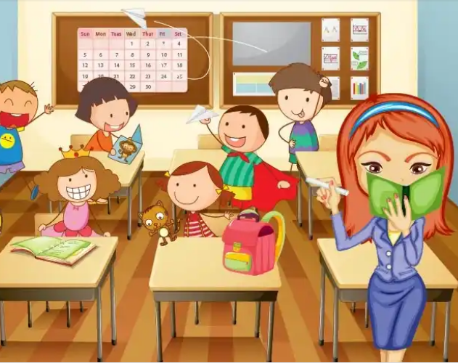
We have clear expectations of behaviour and conduct at TBOS that are for the benefit of the school community as a whole. These expectations support the development of the TBOS learner attributes and are centred about mutual respect, trust and responsiveness.
Through these expectations, we seek to establish secure and caring environment in which imagination is kindled and potential fulfilled. Learners must follow all rules and procedures in the classroom, gallery, multi-purpose hall and football field. The school will not tolerate any act of indiscipline from any learners; hence parents are advice to engage their wards during this break as the school will not hesitate to expel recalcitrant learner.
Learners who deface, damage or destroy school material or property will be subjected to disciplinary action and require to make financial reimbursement.
CONTRABAND ITEMS
The following items, which may be hazardous or a distraction to others, may NOT be brought into school-
- Weapons (knives, catapults etc,) including replicas.
- Drugs and drug-related items (unless medically prescribed)
- Any form of alcohol and tobacco
- Undesirable picture, books, magazines
- Firecrackers, lighters or matches
- Expensive toys, expensive jewellery
- Liquid paper ( correction fluid)
- Chewing gum
- Snacks and water bottle

PARENTS ATTITUDE TO STAFF AND FELLOW PARENTS:
Anywhere you find children, even at home, there’s bound to be misunderstanding from time to time either between staff, parents or children. We sincerely crave your indulgence to handle this with maturity. Abusing people in the presence of your wards is unethical. Let us stop abusing fellow parents and teachers at will. We are one big family sharing the same vision, mission and core values, so let us work together in love.
Please, in case of any misunderstanding, report the issue to the Vice Principal Administration, for amicable settlement.
In conclusion, we wish all our learners a wonderful half term break. Do well to ensure they complete all project work/assignments because it is part of their assessment.

Feel free to contact us via this whatsapp number (+234 810 444 6168) if you feel there are issues regarding the welfare and performances of your ward(s) that needs to be addressed.
CONTACT ADDRESS:
Plot 4 Federal Housing Estate, Uratta road off MCC Road, Owerri. Imo State
+2348037503627, +2348104446168
info@thebrodoakschool.com
www.thebroadoakschool.co

God bless you all. Stay safe!

